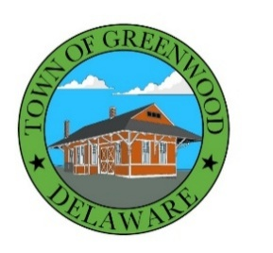
TOWN OF GREENWOOD DELAWARE
100 W. Market St., P.O. Box 216 Greenwood DE 19950
Ph# 302-349-4534 Fax 302-349-9332

SPECIAL MEETING
December 8, 2025
6:30 pm
AGENDA

- CALL TO ORDER / PLEDGE OF ALLEGIANCE

- PUBLIC COMMENT
The Public Comment portion of the Town Council Meeting affords members of the public the opportunity to share with the Town Council questions, thoughts, comments, concerns, and/or complaints regarding the Town. Anyone interested in addressing the Town Council will be given three (3) minutes to do so. The Town Council is sincerely interested in hearing from the public, but the purpose of public comment is for Council to listen to comments, and the Town Council is not required to answer questions or provide immediate responses to concerns raised during public comment. The council may take action on items only when duly noticed on an agenda.

- EXECUTIVE SESSION
Executive Session for strategy sessions and advice or opinions from an attorney-at-law regarding pending or potential litigation and to discuss personnel matters in which the names, competency and abilities of individual employees will be discussed and strategy sessions and advice or opinion from an attorney-at-law regarding pending or potential litigation 29 Del. C. § 10004(b)(4) & (9).

- POTENTIAL ACTION REGARDING MATTERS DISCUSSED IN EXECUTIVE SESSION

- DISCUSSION AND POTENTIAL ACTION REGARDING COMPETENCE AND PERFORMANCE OF A PARTICULAR EMPLOYEE, HELD IN OPEN SESSION PERSUANT TO EMPLOYEE REQUEST

- ADJOURNMENT

In accordance with 29 Del. C. §10004(e)(2), this Agenda was posted on 12/1/2025 at least seven (7) days in advance of the meeting.

Agenda items may be considered out of sequence.

NOTE: AGENDA SHALL BE SUBJECT TO CHANGE, AT OR BEFORE THE MEETING, TO INCLUDE ADDITIONAL ITEMS (INCLUDING EXECUTIVE SESSIONS) OR THE DELETION OF ITEMS (INCLUDING EXECUTIVE SESSIONS), WHICH ARISE AT THE TIME OF THE MEETING. [29 Del. C. Sec.10004 (e)(3)]

