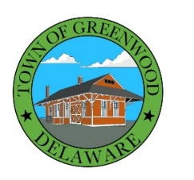
TOWN OF GREENWOOD
100 W. Market St., P.O. Box 216
Greenwood DE 19950
(302) 349-4534

Town Council Special Meeting
September 23, 2025, 6:30 pm

AGENDA
Call To Order

Pledge of Allegiance

- PUBLIC COMMENT
The Public Comment portion of the Town Council Meeting affords members of the public the opportunity to share with the Town Council questions, thoughts, comments, concerns, and/or complaints regarding the Town. Anyone interested in addressing the Town Council will be given three (3) minutes to do so. The Town Council is sincerely interested in hearing from the public, but the purpose of public comment is for Council to listen to comments, and the Town Council is not required to answer questions or provide immediate responses to concerns raised during public comment. The council may take action on items only when duly noticed on an agenda.
- NEW BUSINESS
- Discussion and vote regarding the retainer for Luff and Associates, PA CPAs.
- ADJOURNMENT

In accordance with 29 Del.C. §10004(e)(2), this Agenda was posted on 9/16/2025 and at least seven (7) days in advance of the meeting.

Agenda items may be considered out of sequence.

NOTE: AGENDA SHALL BE SUBJECT TO CHANGE, AT OR BEFORE THE MEETING, TO INCLUDE ADDITIONAL ITEMS (INCLUDING EXECUTIVE SESSIONS) OR THE DELETION OF ITEMS (INCLUDING EXECUTIVE SESSIONS), WHICH ARISE AT THE TIME OF THE MEETING. [29 Del. C. Sec.10004 (e)(3)]

