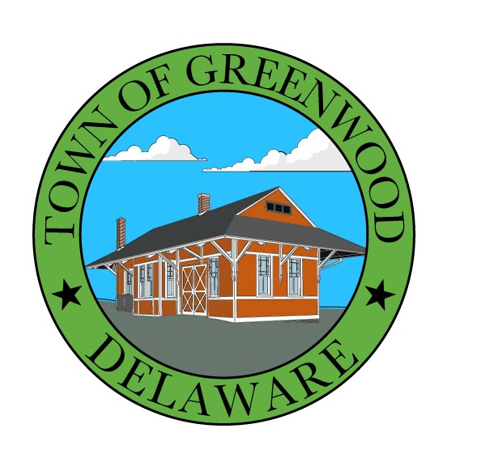 TOWN OF GREENWOOD

TOWN COUNCIL MEETING

100 W. Market Street

Wednesday, April 13, 2022 @ 6:30 P.M.

APPROVAL OF MINUTES
- Town Council Meeting Minutes March 9, 2022

POLICE
- Verbal Report

TOWN MANAGER REPORT
- Verbal Report – Janet Todd

OLD BUSINESS

NEW BUSINESS
- Resolution to annex Morelli property
- Ordinance A22A for approval with recommendations from Planning Commission
- Employee handbook revisions for adoption
- Discussion of proposed vacation carry over and comp time by Chief Thomas

EXECUTIVE SESSION
- Executive session to discuss personnel matters in which the names, competency and abilities of an individual employee will be discussed
- Discussion of possible litigation
(29 Del. C. & Sec.10004 (b)(9).

RETURN TO OPEN SESSION
- Discussion and possible action on matters discussed in executive session.

ADJOURNMENT

NOTES:
AGENDA SHALL BE SUBJECT TO CHANGE TO INCLUDE ADDITIONAL ITEMS (INCLUDING EXECUTIVE SESSIONS) OR THE DELETION OF ITEMS (INCLUDING EXECUTIVE SESSIONS), WHICH ARISE AT THE TIME OF THE MEETING. [29 Del. C. Sec.10004 (e)(3)].

ALL ITEMS ON THE COUNCIL MEETING AGENDA ARE SUBJECT TO A POTENTIAL VOTE.

AGENDA ITEMS MAY BE CONSIDERED OUT OF SEQUENCE.

In accordance with 29 Del.C. §10004(e)(2), this Agenda was posted on April 6, 2022, at least seven (7) days in advance of the meeting.

