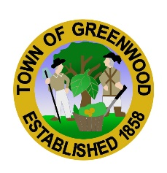
Parade Invitation
“A Country Christmas”
Hosted by the Town of Greenwood

We would like to invite your organization to participate in our first annual Christmas parade! We look forward to bringing the spirit of the season to the town of Greenwood on Friday, December 10, 2021 at 7:00 p.m. We look forward to your participation in what we hope will become a tradition to help celebrate the holiday season. If you are interested in participating please complete the registration information below and return to Town Hall.
Town of Greenwood Christmas Parade 2021
Entry Form

Contact Name: _____________________________________________________

Telephone: ________________________________________________________

Address: __________________________________________________________

Email: ____________________________________________________________

Group Name: ______________________________________________________
Group name will be used for announcements.

Parade Entry: ___Classic Auto Group ___Float ___Truck/Car Club ___Motorcycle Club ___Farm Machinery ___High School Band ___Middle School Band ___Walking Group ___Dance Team ___Fire Company ___Pageant Winners ___Animal

Other (Please describe and include the size and description of your unit): ____________________________________________________________________________________________________________________________________________________________________________________________________________________________________________________________________

Mail entry to Town of Greenwood, Attn: Parade Committee, P.O. Box 216, Greenwood, DE 19950
Or email greenwoodtownof@gmail.com
Please contact Town Hall at 302-349-4534 if you have any questions.

We will send correspondence with additional details to participants once form is received. All entry forms must be received no later than November 24, 2021.

