August 2020 Newsletter

What did the big flower say to the little flower? Hi bud!
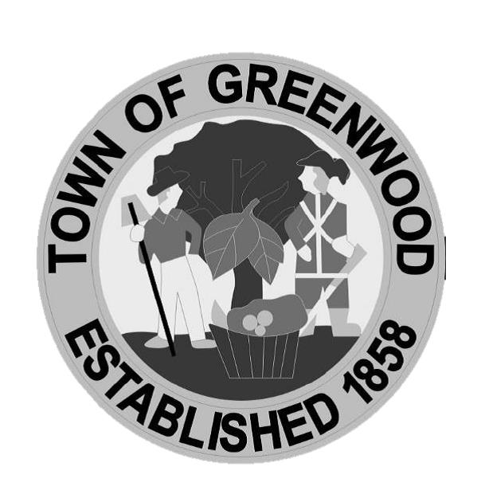

Police Department

Announcements

Road Closure- The Greenwood Fire Department will be conducting their annual hose testing on Tuesday, August 4th, on Schulze Road, South of Council Road, from approximately 0830 to mid-afternoon. Please expect closures in the area.

Newsletters – Now available on our website: greenwood.de.gov., posted at the Greenwood Post Office and Library, as well as, the display box located next to our Payment Drop Box. If you have suggestions for the Newsletter, please contact Town Hall at 349-4534.

Updated Post Office Hours – Effective Saturday August 8, 2020, the Greenwood Post Office retail window will be closed daily for lunch from 1:00 pm to 2:00 pm. The PO Box section lobby will remain open during the time that we are closed for lunch. The PO Box Lobby area will remain open 24 hours per day 7 days per week. Our New Retail Window hours are as follows: Sat - 8:30 am – 12:30 pm, Sun – Closed, and Mon – Fri 8:30 am-1:00 pm, 2:00 pm – 5:00 pm. Closed 1:00 pm – 2:00 pm lunch. For any questions or concerns you may contact Denise Jackson, Postmaster at (302)349-4006. Thank you for using the US Postal service for all your mailing and shipping needs. We greatly appreciate your business and the opportunity to serve you.

Bay to Beach Builders – Congratulations to Greenwood’s Bay to Beach Builders on being voted for the second year in a row, 2020 BEST Homebuilder in Sussex County by Coastal Style magazine. You can also now visit their newly opened Idea Home & Design Studio in Ocean View.

Certificate of Occupancy – Upon completion of new construction, please be advised that you need a Certificate of Occupancy from the Town, plus Sussex County. Please contact Town Hall for further information.

COVID-19 Update – As recommended by Governor Carney, our offices remain closed to the public, except by appointment. Please call Town Hall at 349-4534, to set up an appointment if you need personal attention to your concern. Reminder you can make payments online or utilize our drop box, 24/7 on the East side of Town Hall.

2021 Reminders – We will be accepting applications starting this September, for 2021 Rental Licenses for any property owner who rents property inside town limits and applications for 2021 Business Licenses for anyone doing business inside town limits. Please visit our website for forms and payment options.

Ordinance A-3 Reminder: Section 4 – “It shall be unlawful for the owner of any property or the tenant of an owner to permit or maintain the growth of any grass more than eight (8) inches in height anywhere in the Town of Greenwood and the growth of grass higher than eight (8) inches is hereby declared detrimental to the public health, safety, and general welfare of the property owners and residents of the Town of Greenwood and a common and public nuisance.”

Yard Waste – Yard Waste may be taken to either Delaware Solid Waste Authority location: Ellendale (302) 422-8632 or Bridgeville (302) 337-3521. Please call them for specifics. Remember yard waste is not allowed in the Town trash containers. The burning ban remains in effect from May 1st through October 1st.

Greenwood Library – Although the library remains closed at press time, please visit their website greenwood.lib.de.us for all the programs they are offering, including virtual programs. You can also contact the library at (302) 349-5309.

