2020 First Quarter Newsletter

Scheduled office closures for this quarter: April 10th and May 25^{th.} Reminder you can make payments online or utilize our dropbox.
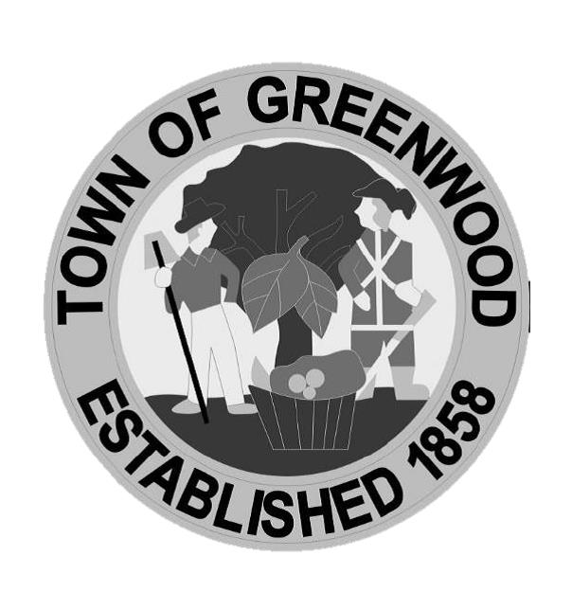

Police Department

Announcements
Easter Egg Scavenger Hunt- The Greenwood Police Department will be hosting an all ages Easter Egg Scavenger Hunt through town during the week of April 13-17^{th.} There will be two eggs hidden each day with clues for their location on our social media pages. Each participant may only find one egg during the entire week. Prizes can be claimed at the PD during office hours until April 30th.
Drug Take Back- Don’t wait for a Drug Take Back Day, we have a permanent drug collection drop box! You can drop off your expired or unwanted medications at the Police Department Monday-Friday 8am-5pm.

You can find details about all of our upcoming events and/or announcements on our social media and website.

Ordinance E-1, Section 7- I – It shall be unlawful for any person to discharge or cause to be discharged any storm water, surface water, groundwater, roof runoff, interior to exterior footing drainage, subsurface drainage, cooling water or unpolluted industrial process waters to any sanitary sewer.
Sewer Flows – We ask all Greenwood residents to make sure that you do NOT discharge or pump any water from a basement sump pump, downspout and/or any type of ground water/run-off into the Town’s sanitary sewer system. The Town of Greenwood spends considerable funds to have all of the Town’s wastewater properly treated and disposed of. Any unnecessary flow is a waste of dollars. In an attempt to keep rates as low as possible, we ask all residents to double check this important issue. See above Ordinance E-1, Section 7.
2020 CENSUS – You will be receiving in early April the 2020 Census. All citizens need to be aware of how important it is for everyone to be counted. The previous census showed Delaware being just short of 1 million residents. Exceeding that 1 million number would make Delaware eligible for an additional congressman. Also, grant funds to the Town are based on population. Websites: www.census.gov and/or www.uscensus.org are two that can be explored now, but please do your part to be counted.
Bulk Trash Pick-Up – The Town of Greenwood will have our bulk trash pick-up on Saturday, May 9, 2020 starting at 6am. Please have your materials placed at the curb prior to the pick-up date. Trash items will ONLY be collected from houses that receive the regular Friday trash pick-up. Items that will NOT be collected: yard waste, automotive batteries, tires, construction debris, flammable/hazardous materials, oil/petroleum products, paint, rock, bricks, concrete blocks, dirt, stumps, or appliances containing CFC/Freon gas (AC units, freezers, refrigerators).
Yard Waste – Yard waste may be taken to either Delaware Solid Waste Authority location: Ellendale (302) 422-8632 or Bridgeville (302) 337-3521. Please call them for specifics.
Chicken BBQ- The Greenwood Volunteer Fire Department’s weekly chicken BBQ will start Friday, April 17th.

