November 2019 Newsletter
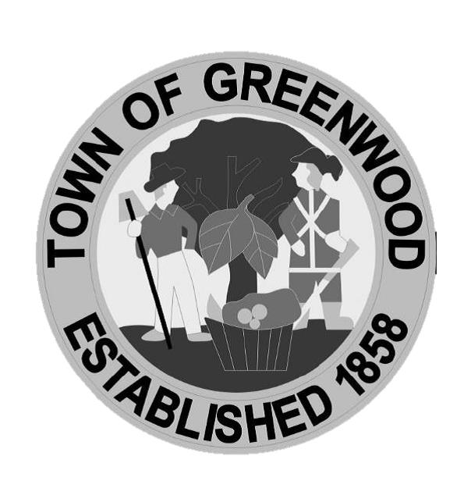

Police Department

Announcements

Angel Tree- The Department will be hosting an Angel Tree for a local family in need this Holiday Season. Come pick a tag off of our Christmas Tree in the Town Hall lobby starting November 25th. New unwrapped gifts can be returned to the PD with the tag attached by December 20th at 5pm. Contact the PD with any questions.

Challenge Coins- Our first Challenge Coin is available for purchase at the Police Department for $10! All proceeds will go towards our community events, such as, the Angel Tree fund and Night Out. If you would like to purchase one please contact Shelley, we appreciate your support!

Emergency Response- Please make sure you have house numbers clearly visible on the front of your home so that Police, Fire Department and Paramedics can easily locate your home in case of an emergency.
Credit Card Payments- The Town of Greenwood accepts credit card payments on the town website www.greenwood.delaware.gov for all monies owed to the town. If you would like to set up a monthly automatic payment, you may come into the office to complete the set-up process. Please bring your credit/debit card and we will set up the payment to automatically post each month.
Fall Clean Up- As you complete your fall clean-up projects, please remember to not blow your leaves or lawn debris on the sidewalks or into the street. Also, please remember that Greenwood is a pet friendly community and respect your neighbors by cleaning up any waste from your pets.
Town Office Holiday Closing- The Town office will be closed on Thursday Nov. 28, 2019 and Friday Nov. 29, 2019 in observance of the Thanksgiving holiday. Payments may be placed in the drop box or processed online.

Greenwood Library Press Releases – December:
Expressions of Joy Harp Concert- On Saturday, December 7th at 11 a.m. at the Greenwood Library, the Expressions of Joy Harp Ensemble will present a delightful concert of Christmas music. The program is free and open to all and registration is not required; children under 12 must be accompanied by an adult. This concert is sponsored by the Friends of the Greenwood Library.
Christmas Caroling at the Country Rest Home- On Friday, December 13th, from 6:00 to 8:00 p.m., the Greenwood Public Library will host a Christmas Caroling Party at the Country Rest Home in Greenwood. Participants will meet in the lobby of the Rest Home at 6 p.m., sing carols throughout the facility, and end the evening with refreshments in the dining room. The activity is open to all; however, children under 12 must be accompanied by an adult. Registration is encouraged but not required.
Homemade goodies are a special treat to the residents; if you are able to supply some of your homemade Christmas cookies as refreshments, contact Robin at 349-5309.
The Country Rest Home is located at 12046 Sunset Lane in Greenwood. For questions, or to obtain directions to the Country Rest Home, call 349-5309.
Loose-Ends Knitting Club- Loose Ends Knitting Club has new hours for the Winter months, starting Tuesday, December 17th at 3:00 p.m. Spend the afternoon with knitters of all skill levels. Materials are provided and free of charge.
OWLs (Older & Wiser Living) Program for Seniors 50+ from Peninsula Home Care- On Friday, December 20th at 10:30a.m. at the Greenwood Library, Peninsula Home Care will hold meetings of the OWLs (Older and Wiser Living) Club with programs with topics of interest to seniors 50+. Membership in the OWL Club is free and provides seniors with tools and resources that allow them to work in partnership with their healthcare team to prevent and manage challenges today and down the road. Possible topics for the monthly programs include stretching classes, fall prevention, hydration, nutrition, and much more. The programs are free and open to all, and registration is required. To register, or for further information, please contact the library at 349-5309 or visit www.greenwood.lib.de.us
Roblox Night- On Friday, December 20th, from 6-7:30 p.m., teens and tweens ages 10+ are invited to spend an evening playing ROBLOX in the Library’s Teen Room. Space is limited, to register today – click the links below or call 349-5309 and register for any or all of them. Late arrivals may find they have forfeited their seat to the waiting list. Kids under the age of 12 must be accompanied by an adult.
Mind Reader's Teen Book Club @ Amity- On Saturday, December 21st at 1:00 p.m., teens 16+ are invited to join the Mind Readers Club and gather at the Amity Coffee Shop to discuss books over coffee. Come ready to talk about a favorite title and enjoy a free beverage and cookie. The Amity Coffee Shop is located at 13 Market Street.
Christmas Movie: The Grinch- Come out to the Greenwood Library on Monday, December 23rd at 2:00 p.m. for a fun family movie day! Bring a pillow and a blanket. Snacks will be provided.
Annual Winter Book Sale- The Greenwood Library will be having their huge annual winter book sale from January 2nd-21st with special deals!

