October 2019 Newsletter
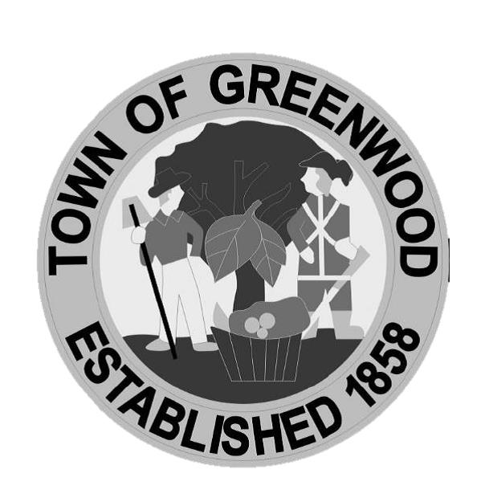

Police Department

Announcements

Halloween Safety Tips:

-If your child is wearing a mask, make sure the eye holes are large enough so they can see out.

-Provide flashlights or glow sticks for lighting.

-Keep all decorations away from open flames, such as cornstalks or crepe paper. And keep decorations and debris out of walkways to avoid tripping hazards.

-Stay within familiar areas and surroundings.

-Trick or Treat in groups.

-Always inspect candy prior to eating. Discard all unwrapped or loosely wrapped candy.

-Remember to turn your porch light on if you are a trick or treat stop!

Upcoming Events:

-October 29: Public Safety Trunk or Treat, 5-7pm, at Georgetown DMV

-October 31: Community Trick or Treat, 6-8pm. There will also be a Trunk or Treat event during this time at Greenwood United Methodist Church.

Fall Clean Up – As you begin your fall clean-up projects, please remember to not blow your leaves or lawn debris on the sidewalks or into the street. Also, please remember that Greenwood is a pet-friendly community and respect your neighbors by cleaning up any waste from your pets.

Credit Card Payments – The Town of Greenwood now accepts credit card payments of monthly utilities, taxes and other town fees. Customers can make payments at Town Hall- Mon-Fri.- 8am- 5pm. or online using the Town website: www.greenwood.delaware.gov. There is a fee of $2.50 for bills up to $75.00 and any bills over $75.00 will incur a 3% fee added to the total amount due for processing.

Town Utility Services – Water, sewer and trash are provided to residents and businesses every day. At the end of each month, meters are read, utility bills are prepared and sent to users. Most receive their bills by the 10th day of the month and that bill is for services already received. Payment is due by the last day of the month. Payments made later than the last day will be LATE and will receive a late penalty. Please include this utility bill in your monthly Budget to avoid extra penalties and keep the abundant clean water we provide flowing to your home or business. When making a payment, please include the property’s service address, your phone number, name, and account number on the check or envelope and please return the payment stub with your payment. Thank you for your on-time payments.

Update Contact Information – Please help us connect with you in a faster and easier method when necessary by providing your email address and/or emergency contact information should the need arise.

Greenwood Library Press Releases – November:

Flu Shot Clinic-On Monday, November 4th, from 10:30 a.m. to 1:30 p.m., Kent Pharmacy will be offering a flu shot clinic at the Greenwood Library. Flu shots will be available for those 9 years of age and older, administered by a pharmacist. No registration is required; please bring a photo ID and insurance card. For those without insurance, the cost of the shot is $29.00. People are encouraged to wear clothing that enables easy access to the upper arm. For further information, contact the library at 349-5309.

Computer Classes for Beginners-Beginning Tuesday, November 5th, and continuing every other Tuesday for 4 sessions, at 2:30 p.m.at the Greenwood Library, computer classes for beginners will be offered. The topics to be covered include: November 5: Mouse and Keyboard Basics; November 19: Computer Basics; December 3: Internet Basics; and December 17: Outlook Email Basics. The classes are free and open to all 12 years and older. Laptops are provided or you may bring your own. Registration is encouraged but walk-ins are welcome. To register, visit www.greenwood.lib.de.us, drop by the library, or call 349-5309.

Family Game Night-On Friday, November 8th, from 5:30 to 7:30 p.m., at the Greenwood Library, the whole family is invited to enjoy such games as Family Feud, Dutch Blitz, Apples to Apples and more. The program is free and open to all ages, and no registration is required. Children under 12 must be accompanied by an adult. Light refreshments will be provided.

Book Talk and Signing: Tubman Travels with author Jim Duffy-On Thursday, November 14, at 6 p.m. at Amity Coffee at 13 W. Market St., Greenwood, author Jim Duffy will discuss his book, Tubman Travels: 32 Underground Railroad Journeys on Delmarva. Mr. Duffy will share Underground Railroad stories and discuss the life lessons learned and key discoveries made while writing the book. The presentation will be followed by a book signing opportunity. The program is sponsored by the Greenwood Public Library which is providing a complimentary Amity Coffee beverage, with a limit of $4.00, for every attendee. The program is free and open to all, and no registration is required. Children under 12 must be accompanied by an adult. For further information, call the library at 349-5309.

OWLs (Older & Wiser Living) Program for Seniors 50+ from Peninsula Home Care-On the third Friday of every month, at 10:30a.m. at the Greenwood Library, Peninsula Home Care will hold meetings of the OWLs (Older and Wiser Living) Club with programs with topics of interest to seniors 50+. Membership in the OWL Club is free and provides seniors with tools and resources that allow them to work in partnership with their healthcare team to prevent and manage challenges today and down the road. Possible topics for the monthly programs include stretching classes, fall prevention, hydration, nutrition, and much more. The programs are free and open to all, and registration is required. To register, or for further information, please contact the library at 349-5309 or visit www.greenwood.lib.de.us

Roblox Night-On Friday, November 15th, from 6-7:30pm, teens and tweens ages 10-18 are invited to spend an evening playing ROBLOX in the Library’s Teen Room. Space is limited, to register today –call 349-5309, visit the library or www.greenwood.lib.de.us and register for any or all of them. Late arrivals may find they have forfeited their seat to the waiting list. Kids under the age of 12 must be accompanied by an adult.

Mind Reader's Teen Book Club @ Amity-On Saturday, November 16th at 1pm, teens 16+ are invited to join the Mind Readers Club and gather at the Amity Coffee Shop to discuss books over coffee. Come ready to talk about a favorite title and enjoy a free beverage and cookie. The Amity Coffee Shop is located at 13 Market Street.

Loose Ends Knitting Club-Beginning knitters of all ages are invited to the Teen Room, on Tuesday, November 19th at 6:30pm, for self-paced guidance and instruction. Materials provided.

Adult Art Class Hanging Mason Jar Vase-On Friday, November 22, at 5:30 p.m. at the Greenwood Library, artist Jenell Willey will teach participants how to create a rustic Hanging Mason Jar Vase. We will be painting and aging a mason jar to give it a shabby chic feel. We will then attach the mason jar to a wooden board making it ready to hang on your wall! We will also be creating a seasonal floral arrangement with silk flowers/foliage to place in the completed mason jar. Free and open to all 16 and older; registration is required. To register, visit www.greenwood.lib.de.us, call 349-5309, or drop by the library.

Art Factory-Come and join Miss Charis at the Greenwood Library for a fun evening at the Art Factory on Friday, November 22nd at 5:30pm. We will explore the use of warm and cool colors through the creation of a unique and vibrantly shaded tree. This class is for 8-12 year olds. To register, visit www.greenwood.lib.de.us, call 349-5309, or drop by the library.

