September 2019 Newsletter
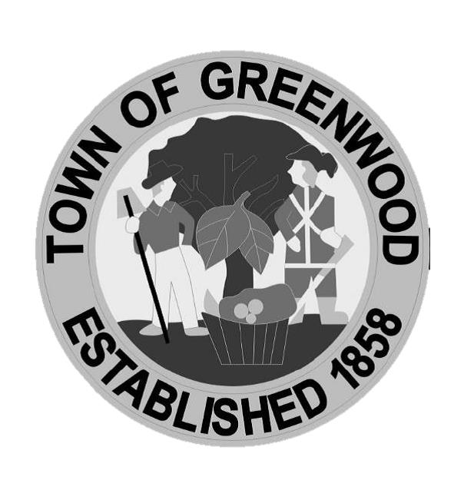

Police Department

Announcements
-We would like to thank everyone that attended our Night Out, we had a great night and look forward to next year!

-School is back in session, please be mindful of children and buses in the area.

-September is National Preparedness Month! This presents an opportunity to make sure your family is prepared for disasters that could potentially affect our community or your household. It is better to be prepared now so you can take action when it is needed. The Department of Homeland Security has great resources on their website at www.ready.gov.

Credit Card Payments – The Town of Greenwood now accepts credit card payments of monthly utilities, taxes and other town fees. Customers can make payments at Town Hall- Mon-Fri.- 8am- 5pm. or online using the Town website: www.greenwood.delaware.gov. There is a fee of $2.50 for bills up to $75.00 and any bills over $75.00 will incur a 3% fee added to the total amount due for processing.

Town Utility Services -- Water, sewer and trash are provided to residents and businesses every day. At the end of each month, meters are read, utility bills are prepared and sent to users. Most receive their bills by the 10th day of the month and that bill is for services already received. Payment is due by the last day of the month. Payments made later than the last day will be LATE and will receive a late penalty. Please include this utility bill in your monthly Budget to avoid extra penalties and keep the abundant clean water we provide flowing to your home or business. When making a payment, please include the property’s service address, your phone number, name, and account number on the check or envelope and please return the payment stub with your payment. Thank you for your on-time payments.

Yard Waste – Yard waste may be taken to either Delaware Solid Waste Authority location: Ellendale (302) 422-8632 or Bridgeville (302) 337-3521. Please call them for specifics. Burning Ban will be in affect from May 1st through October 1st.

Ordinance A-3 Reminder: Section 4 – “It shall be unlawful for the owner of any property or the tenant of an owner to permit or maintain the growth of any grass more than eight (8) inches in height anywhere in the Town of Greenwood and the growth of grass higher than eight (8) inches is hereby declared detrimental to the public health, safety, and general welfare of the property owners and residents of the Town of Greenwood and a common and public nuisance.”

Update Contact Information -- Please help us connect with you in a faster and easier method if/when necessary by filling out the attached questionnaire and returning it with your utility payment or mailing back to Town Hall at 100 W. Market Street, Greenwood, DE 19950.

Greenwood Library Press Releases – September:

Loose-Ends Knitting Club – On Tuesday, September 17th @ 6:30, beginning knitters of all ages are invited to the Teen Room at the Greenwood Library for self-paced guidance and instructions. Materials provided.

OWLs Club – Starting up again September 20th, on the third Friday of every month, at 10:30 a.m. at the Greenwood Library, Peninsula Home Care will hold meetings of the OWL (Older and Wiser Living) Club with programs with topics of interest to seniors 50+. Membership in the OWL Club is free and open to all. To register, or for further information, please contact the library at 302-349-5309 or visit www.greenwood.lib.de.us.

Drop in Lego Playtime – Do you want something fun to do on your day off from school? Come build with us on Friday, September 20th from 12:00 – 3:00 p.m. at the Greenwood Library! We will have traditional Legos out for construction, as well as, the giant cardboard building blocks! No registration is required. Just come and have fun!

Rock Painting Fun – Come out to the Greenwood Library on Friday, September 20th at 3 p.m. and have fun painting rocks! You can hide them around town or keep them for yourself! This event is open to children ages 8-12. Registration is required.

Hard Reads Gamers – On Tuesday, September 24th at 5 p.m., the Greenwood Library will host video gamers ages 16-25 at Greenwood VFW Post 7478. Free and open to gamers only. Register at www.greenwood.lib.de.us or call at (302) 349-5309. The VFW is located 1 block behind the library.

Autism Family Support Group – On Saturday 28th at 11 a.m., families with loved ones living on the Spectrum are invited to share experiences and find encouragement with others in the community at the Greenwood Library. This program is free and open to the public.

French Cuisine with Chef Charles Oppman – On Monday, September 30th at 5 p.m. at the Greenwood Library, Chef Charles Oppman will present a class on French Cuisine. A door prize and samples are included. Fee and open to all ages 8 and up; children under 12 must be accompanied by an adult and registration is required. To register, drop by the library, call (302) 349-5309 or visit www.greenwood.lib.de.us.

